Renju lesson on March 8, 2001

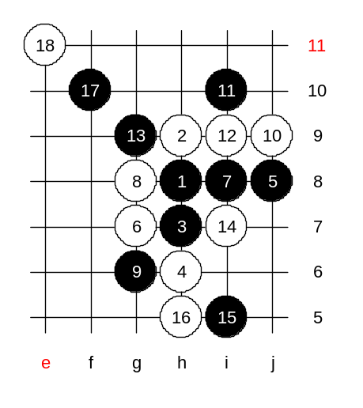
Hello all! Welcome to Online Renju Class. Today is a special situation, we have a lesson outside our regular classroom. I hope the lesson will go smoothly today and the new interface does not bring us too many problems. Next Thursday our class will continue on regular address at www.playsite.com, in renju lobby.
Last week we learned about this 6th move, but black was very strong there because white did not play best moves later. Today we will see how should white play. Last week we played 12-i7, in fact it is the weakest move. There are three other 12th moves which are much better. Which moves are they? Indeed, 12-i9 is the most classical move here. Lets begin with it. Later we will also learn about others. Those 18 moves on the board show the ideas of white’s defense. There is no theory for next moves. It is matter of improvisation. White can defend here without too big problems.

Now, let’s test another 12th move. Any suggestions? I would like to teach you something about 12-f8. That move is quite wild. I explain you the thinking. White looks strong on the left side. So, black must worry about white’s attack. Can anyone tell me, which side is better block for black? So many of you say left. Why left side? Can you explain? The logic is, you have to make the choice by evaluating the outcome. How many of you tried to foresee the moves and evaluate? I assure you, if black blocks below, white has no VCT!! And remember, I always tell you, when you have a choice between defense moves, then choose the one that is most profitable for self. So, we know white does not have VCT> But we did not solve the question which move is more profitable for black. In order to know the usefulness, you have to see some steps forward and evaluate the outcome.
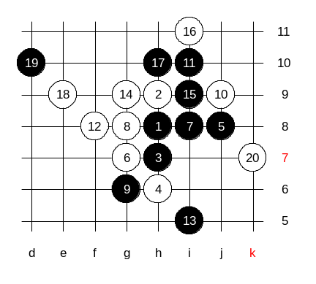
20 stones on board now. Look at the outcome! Black go the tempo, but white is much better now, because black has no VCT of its own.
Do not always count who gets the final tempo, but count about the outcome even after one gets the tempo. This is very very important tactics of renju.
Therefore, even i5 seemed to be good because of absence of white VCT, it turned out to be bad because we did not analyse the final outcome.
We came to the conclusion that black should have played e9, and NOT because we were afraid of white’s attack, but because the outcome is better for black that way!!

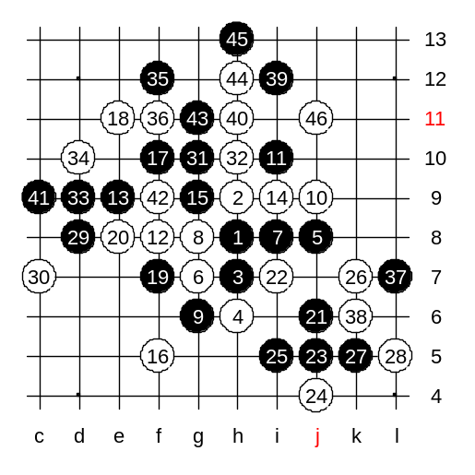
Lets try that e9 now. After black played e9, white got the tempo. But white has nothing to do with that tempo actually. Therefore, the position is turning to black advantage now. Black is surrounding white structures here. Yes, if we make a conclusion from this, then we can conclude that f8 was more like a trap, and if black guessed right block then black got better advantage than in case of 12-i9. I do not have any really good plan here for white. However, I played it once against Ants Soosyrv in the tournament. We played like this. Do you all know Russian renju master Mihail Kozhin (8 dan)? One Estonian renju player, Tunnet Taimla, used this white ideas in his game against Kozhin. And finally the game ended as draw. And note that Tunnet Taimla is just 11 years old. By the 46th move white made a final block. Now black’s attack is dead. Taimla managed to block because he followed the defense concept – to keep black areas separated and not let them connect.

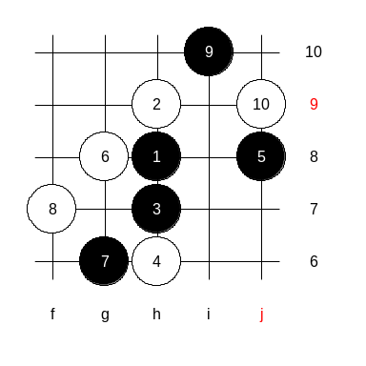
Today is the last lesson of d8 opening. Next week we will begin with new opening.

This is the medium level homework. Please find the black win.

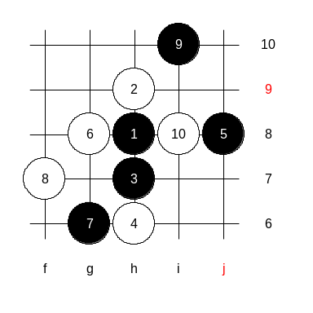

This is the advanced level homework. Please find the black win.

